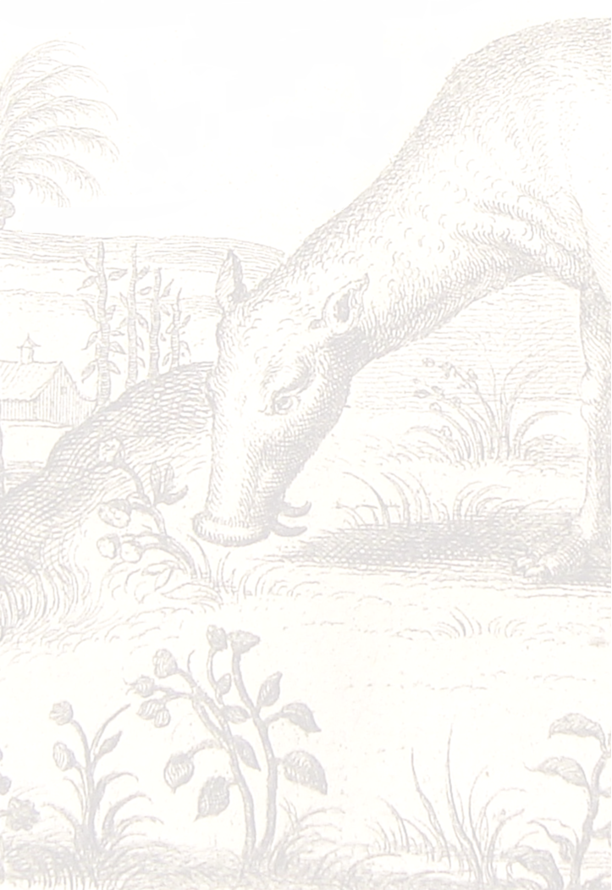
British Animal Studies Network

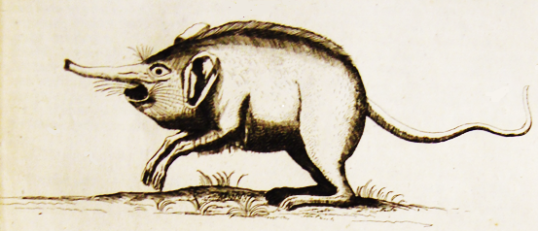

‘Smelling’
20 and 21 May 2016 at the University of Strathclyde

Paper abstracts and
speaker biogs

Abstracts
Plenaries
Andrew Gardiner, ‘A veterinary anatomy of olfaction’
The sensory world of domestic animals must be very different from our own yet no attempt is made to integrate this into routine husbandry and care. Companion animals' sociable smelling of each other's bodies usually elicits some discomfort in their people. But if the smell of a dead fox or bird is so appealing to a dog, then how does she experience a Glade plug-in room diffuser? In this paper, I will attempt a veterinary anatomy of smelling, starting with some observations taken from my own dogs, then adopting a morphological and comparative anatomical approach to the nose and vomeronasal organ. We will also try to experience one aspect of what it's like to be a cat.
Susan Richardson, ‘Let My Words Be Bright With Animals’

In this session, poet and performer Susan Richardson will share work from her three published collections, Creatures of the Intertidal Zone, Where the Air is Rarefied and skindancing (all published by Cinnamon Press), as well as new work that has recently emerged in the course of her poetry residency with the Marine Conservation Society. One of the themes running through the performance will be that of animal-human metamorphosis and both our intimacy with, and alienation from, our animal selves.
Sandra Swart, ‘Rex vs. Rex – the State, the Dog and the Nature of Evidence’
“Scent is an effluvium which is constantly issueing from the pores [which]… comes in contact with the olfactory nerves of the dog and enables him to discover the proximity of the object of pursuit.” South African Commissioner of Police, 1928

“You cannot cross-examine a dog.” Judge, in Rex v. Morake, 1922

Dogs are Nature’s historians. Every tree is a palimpsest. Every park is an archive. The past is everywhere for them – layers of meaning are smelled through over two hundred million sensory receptor sites in their noses (we have a pitiful six million). The olfactory portion of the nasal mucous membrane contains an abundance of nerves connected to the specially evolved olfactory lobe in the dog’s brain. Dogs smell the world before they see it – and the past exists in scent far longer than in sight. This essay focuses on the shifting societal usage and human understanding of canine olfactory ability. It explains the development of detector dogs and their role in offering “evidence” in court – and in the writing of history itself. There is a long and contested history of dogs’ deployment in human law enforcement but from the end of the nineteenth century, dogs were used for one sense in particular: smell.
The South African state has decided, after just over a century of debate in the press and in the courts, that dogs can testify as expert witnesses for the prosecution. A Belgian Malinois named Killer, deployed on anti-poaching patrols in the Kruger National Park with his handler (who cannot be named for his safety), has just won a gold medal for his “testimony” in a Nelspruit court to convict two rhino poachers. The magistrate ruled that Killer’s sense of smell was so precise that there was no chance that he could have linked the wrong men to the corpse. This was Killer’s 117th arrest. However, the judge conceded that his acceptance of Killer’s evidence did not refute two key previous historical judgements on the kind of evidence that could be offered by dogs. In 1920, ten years after dogs were first introduced into the embryonic South African police force, the court in Rex v. Trupedo rejected evidence based on a dog’s sense of smell. In Rex v. Trupedo, the court decided: ‘We have no scientific or accurate knowledge as to the faculty by which dogs of certain breeds are said to be able to follow the scent of one human being, rejecting the scent of all others…’ Nevertheless, the court cheerfully admitted that the decision would not stop dogs being “employed for the purpose of obtaining clues.” (Rex v. Kotcho) There followed a decade of heated debate over the nature of evidence provided by police dogs and a new perception of the role of dogs’ senses in criminal detection. Two generations and seventy years later, at the height of Apartheid, the Appellate Division tested the contention again in State v. Shabalala (1986) and denied the evidence offered by dogs, for a complicated set of reasons. Now, 21 years into a democratic dispensation, the evidence of the dog may finally be used, under very specific conditions.
Using both archival sources and ethnographic material, this paper explores the long history of tracker dogs in South Africa’s law enforcement, within the changing context of detector dogs internationally. It includes the life histories of a few dogs – Sauer, Maxim, Bosco, Flash and Killer – to demonstrate how dogs have been very differently trained and deployed in South Africa over time. It looks at the shifting relationship (and the shifting official perception of the relationship) between dog and “dogmaster” (or handler). It analyses how understandings of dogs’ sensory ability changed – not only as the science of smell developed but because of a changing socio-political zeitgeist. It shows how the public understanding of the dogs’ ability was also manipulated by the South African state. It dissects understandings of the admissibility and value of animal evidence, which opens a lens into broader cultural understandings of human-animal communication. It asks questions about the mutable role of dogs in forensic detection, and discusses contemporaneous understandings and misunderstandings of canine agency and ability over the last century. It thereby explores the tension between the idea of the dog as merely an instrument of scent and the dog as sentient individual – detector versus detective. This essay looks at where the dog’s nose led humans – both practically and intellectually – in the field and in the court over the long twentieth century. It thus looks at ‘sensory history’ from a lot closer to the ground than usual. In essence, it rethinks not only the nature of evidence, but the evidence of Nature.
Panelists
Maan Barua, ‘Olfaction: a more-than-human geography’
This paper is a contribution to more-than-human geographies of olfaction. Whilst smell has featured in geographical exegeses of culture and the economy (see Nigel Thrift,’All Nose’, 2003), animals’ olfactory modalities, their influence on social and spatial configurations, have received scant attention. To this end, this paper first shows how nonhuman capacities for odour have bearings upon human labour and rural livelihoods. Secondly, it highlights hidden influences of nonhuman olfaction in mediating political situations and economic activity. Thirdly, the paper attends to the spatialities of olfaction to show how the realization of smell has uneven effects and asymmetric ecologies. These more-than-human geographies of olfaction are empirically grounded through an in-depth ethnographic and ethological study of elephants and people in rural India. Its focus is a milieu riven by conflict and mediated by volatile material – alcohol – that humans brew and elephants sense. The paper concludes by discussing the wider implications of nonhuman olfaction for thinking through animals’ geographies and the more-than-human collectives within which social lives are lived.
John Clayton, ‘“Knowing fish and seeking ot(ters)hers”, a multi-species olfactory sensorium as method and situated knowledge’
Animal geography has latterly turned its attention toward innovative methodology in an effort to address notions of parity in flattened ontologies. This paper reveals how ‘smelling’ became an instrumentalised sense in the seeking of both specimen carp and otters during a recently completed multi-species ethnography. Specimen carp fishing is one of the most popular participation sports in the UK and brings significant revenue to the rural economy every year. The resurgent success of the European Otter has resulted in the predation of specimen fish prized within this angling culture and the resultant conflict provides a window through which some novel more-than-human relationships are revealed. A process of attunement and embodied knowledge practices will be explored, reflecting the manner by which the non-human comes to discipline the actions and movements of the human in acquiring their presence. In producing a performance on the part of Carp an intimately connected web of affects, temporalities, situated knowledge and anticipatory technologies extend the capacity of the human into the umwelt of the animal, forming a series of sensorial milieu that exist in a state of immanent potentiality.
Lucinda Cole, ‘Carrion and Species Being in the Eighteenth Century’
This paper addresses the relationships among scavengers, animality, stadial theory, and the biopolitics of smell. In all human and animal cultures, the difference between the “fresh” and the “rotten” is largely determined through smell and taste; yet in his Anthropology, Kant describes these two sense as being “lower” than those of touch, sight, and hearing. I trace this assumption back through eighteenth-century voyage literature, through its accounts of scavenging to Adam Smith and stadial theory, the armchair anthropology that uses specific feeding practices in the human and animal world to create a general theory of development and to place specific cultures within it. The arbitrary nature of these taxonomies and the sense of smell on which they are partly based is especially apparent in the discourse of carrion eating. As William Boseman’s A New and Accurate Description of the Coast of Guinea Divided Into the Gold, the Slave, and Ivory Coasts (1705) and Captain Cook’s Voyages Around the World (1768-71), among others, make clear, the word “carrion” refers both to a decaying animal and to any creature, including live game, whose flesh can be described as unpalatable. Slippages between these two definitions of “carrion”—one associated with taste, the other with putrescence--point to the fragile and barely-constructed differences between the feeding habits of Europeans and those of presumably more “primitive” races. While smell, unlike vision, rarely rises to be the subject of literary and political criticism, I argue that it is critical for animal studies, food studies, and post-colonial studies, where it has served as a marker of a species being and of human-animal difference.
Erika Cudworth, “It smells good to me!” Embodied affectivity in the posthuman home
This paper draws on an ethnographic study undertaken in two locations in the UK - East London and rural Leicestershire in the midlands of England. Fifty two people were interviewed about their experiences of living with dogs. The resulting data is extensive, and this paper discusses one theme -- everyday life in the shared space of ‘home’, focusing specifically on the challenges raised by dogs’ abilities and preferences when it comes to smell. Many homes are multi-species spaces and while some people try to demarcate their own territories within the home, much space – including the most intimate spaces – is shared. Dogs bring a variety of olfactory challenges into the space of home: piss and shit, bad breath and farting, and peculiarly dog assertions of what constitutes a desirable perfume or a delicious snack. Dogs also smell so differently to humans that misunderstandings can occur – food which is out of sight is not often out of sniff. Yet living with animal companions muddies embodied boundaries, such as those between humans and other animals, of ‘family’ and emotional and affective relations. Consequently, living well with a dog means making a wide variety of changes and sometimes radical accommodations. Human disgust at the smells a dog makes or brings into the home is surrounded by narratives of tolerance and acceptance. Dog ingenuity in finding and keeping food is woven into humorous tales. Being intimate with dogs also invites a reappraisal of what ‘smells good’.
Fenella Eason, ‘Human-canine engagement through smell: Canine prowess in scent detection advances life-management practices for their human carers with Type 1 diabetes’
The macrosmatic or keen sense of smell enjoyed and employed by dogs, rats, pigs and the majority of animals, compares unfavourably to our own and other primates’ feeble olfactory abilities. The exceptional canine capacity for highly accurate odour perception has become significantly useful to humans in the search for illicit drugs, buried bodies or explosives. An additional value has been found within biomedical exploration where canine olfactory prowess in the field of scent detection, is adapted to benefit human health and wellbeing in chronic illness. My multispecies ethnographic research explores a mutualistic human-canine coexistence founded on the latter’s acute scenting capacity. Medical alert assistance dogs learn to give advance warning signals to their Type 1 diabetic partners if blood glucose levels rise or fall to unsafe extremes. This innovative co-embodied care practice encourages or renews human social integration, highlighting the other species’ capacity for warmth and concern for non-canine animals as well as for sensitive odour detection. Human-canine partnerships develop into symbiotic associations as a result of this skill in sensory perception and highlight the gifting of care practiced by each member of the dyad to shape harmonious, and therefore harm-free, living within the limits of Type 1 diabetes.
Clare M Knottenbelt, ‘Pet and owner smell - passive smoking in pets’
Vets rarely ask owners about their pet's exposure to environmental tobacco smoke (ETS). However, the smell of stale smoke adherent to the coat makes it easy to identify affected patients. As an oncologist, questions to owners about what had caused their pet’s cancer when the pet was clearly exposed to ETS are challenging. The presence of the smell is probably only the tip of the iceberg and raises questions about the volume of exposure and the pet’s experience given their more highly developed sense of smell. Pets' self-grooming also raised concerns about ingestion of the carcinogens present in ETS. Our initial studies have assessed hair nicotine concentrations in dogs and cats. This has confirmed that they do take in significant volumes of ETS. Exposure to ETS increased the expression of genes associated with cell damage (CDKN2A) and increased weight gain after castration in dogs. Our ability to smell exposed pets may impact on our attitude to the owners. Personally I always feel sorry for the pets in these circumstances and assume they do not wish to smell that way but in reality we know nothing about how ETS exposure affects the pets on an emotional or psychological level.

Rebecca Marsland / Kate Milosavljevic, ‘“Bees that roar and the smell of the sun”: experiential sensory knowledges in Beekeeping practice’
Most of us are only aware in some small way that the life world of the European honeybee is one dominated by pheromones. Encased as they are within the dark interior of a hive, bees communicate through scent and touch, translating landscapes of polarised sunlight into what we might well describe as a gloriously pungent sensory scent-scape of social exchange. But what of their human keepers? Do odoriferous exchanges of apis knowledge cross species boundaries? How are smells interpreted and encoded by beekeepers, and what does it mean when they make such statements as ‘we can smell if the queen is happy’? The smells of a beehive are many, from the sickly to the sweet. This work in progress from the current 'Beelines' project at University of Edinburgh examines the place of smelling during human-bee exchanges in industrial beekeeping practices, and asks what the act of smelling can tell us about the lives that bees live under our care.

Neil Pemberton, ‘“Bloodhounds as Detectives”: Jack the Ripper, Slum Scent and the Making of Canine Forensics’
This talk explores the emergence of what might be might be called ‘canine forensics’ in the context of one of Britain’s most notable murder investigations – the hunt for Jack the Ripper in 1888. Crucial to this account are the ambitions and practices of Edwin Brough, who systematically bred and trained a new kind of English bloodhound for the purpose of hunting what he called the ‘clean boot’ – that is, human body odour. Brough claimed that his practices transformed ‘scent’ into a traceable forensic clue, insisting that the smelling powers of his hounds were suitable for tracking criminals. During the so-called ‘Autumn of Terror’ of 1888, Scotland Yard recruited Brough and his bloodhounds, but despite trialling the hounds in London parks, no dogs were ever unleashed against the Ripper in the end. Nonetheless, the trials of clean boot bloodhounds for deployment against the Whitechapel killer, however, opened up a journalistic space through which an alternative bloodhound emerged and was projected less as a civilised and pedigreed hound belonging to gentlemen and more a savage, bloodthirsty monster, tolerated only for the purpose of the eradication of yet worse horrors. Drawing primarily on press imaginings and reports, I will discuss how using dogs to hunt human quarry in an environment perceived to be characterised by poverty, depravity and slum scent did not sit easily within the late-Victorian public imagination, serving as a source of profound social and cultural anxiety.

Workshop (after the meeting has ended on Saturday)
Susan Richardson, ‘Writing on the Nose’
This taster workshop will offer participants the opportunity to engage with the BASN meeting's theme of 'smelling' through the writing of poetry. As well as learning, and experimenting with, several ecopoetry techniques, you'll receive brief feedback on any draft/fragments of a poem that you produce.

Biographies
Plenaries
Andrew Gardiner is European Veterinary Specialist in Animal Welfare Science, Ethics and Law, Royal (Dick) School of Veterinary Studies, University of Edinburgh. Andrew worked in veterinary practice for 14 years and has postgraduate qualifications in surgery and a PhD in veterinary history. His research interests are in veterinary education, animal ethics/welfare, community animal health and welfare, and inter-disciplinary animal studies.
Susan Richardson, is a poet, performer and educator whose third collection of poetry, skindancing, themed around human-animal metamorphosis and our dys/functional relationship with the wild and our animal selves, was recently published by Cinnamon Press. Her previous two collections, Creatures of the Intertidal Zone and Where the Air is Rarefied (a collaboration with visual artist Pat Gregory), also published by Cinnamon, focus on her own, and other human and non-human animals’, journeys through the increasingly fragile Arctic environment. Susan is currently poet-in-residence with both the Marine Conservation Society, writing poems and running workshops in response to their Thirty Threatened Species project, and the global animal welfare initiative, World Animal Day. She is the co-founder and poetry editor of Zoomorphic (www.zoomorphic.net), the online literary journal that publishes writing in celebration and defence of wild animals, and a Fellow of the International League of Conservation Writers. Susan has performed at literary, environmental and science festivals throughout the UK, for organisations such as WWF, the ONCA Centre for Arts and Ecology, Friends of the Earth and the Centre for Human Animal Studies, on BBC 2, and at Universities both nationally and internationally. She has also been a regular performer on BBC Radio 4 while resident poet on Saturday Live. As an educator, she has more than sixteen years’ experience of coaxing people of all ages and backgrounds to engage with wildlife conservation and other environmental themes through poetry in an imaginative, dynamic way. She has been visiting academic at Flinders University in Australia and has an ongoing association, as performer and workshop facilitator, with ARCIO (Action Research and Critical Enquiry in Organisations) at the University of Bristol. For further information, please visit www.susanrichardsonwriter.co.uk
Sandra Swart is a Professor of History at Stellenbosch University in South Africa. She simultaneously completed an MSc in Environmental Change and DPhil in Modern History at Oxford University. She recently completed a term as President of the Southern African Historical Society. She is interested in social and environmental paradigms, focusing on the interaction of humans and other animals. Her most recent book is Riding High – Horses, Humans and History in South Africa (Witwatersrand University Press, 2010).
Panelists
Maan Barua is a British Academy Postdoctoral Fellow at the School of Geography and the Environment, University of Oxford. His research is focused on generating new understandings of the politics, spatialities and governance of the living and material world, engaging political ecology and posthumanist thought. Of particular interest are nonhuman ecologies and processes pertaining to production, landscape and knowledge, and situations in which different ecological epistemologies are brought into conflict. Maan’s past and ongoing research projects include work on animals’ geographies, nonhuman labour and the economy, and most recently postcolonial urban ecologies. Maan has a DPhil in Geography from the University of Oxford, and is an Early Career Fellow of Somerville College.
John Clayton’s research adopts a more-than-human paradigm to explore the interactions of anglers’, carp and otters, within specific recreational fisheries which have a history of predation. Within these sites he is exploring how conditions of conflict between humans and non-humans are expressed through enactments of individuation and population. At present he is working on innovative methodological practices that seek to evidence the material and affective connections that exist between humans and animals. At RGS-IBG 2014 he presented a paper in the ‘Historical Animal Geographies’ session, concerning the individuation of a fish named ‘Clarissa’, caught in 1952, and how this became the foundational story of a specialist practice.
Lucinda Cole is a visiting Associate Professor of English at the University of Illinois, and author of Imperfect Creatures: Vermin, Literature, and the Sciences of Life 1550-1750 (University of Michigan Press, 2015) along with a host of articles on animal studies topics. These include “The Raw, the Cooked, and the Scavenged: Beasts of the Southern Wild” (Journal for Critical Animal Studies, 2014); “Human, Animal, and Machine in the Seventeenth Century” (Blackwell Companion to British Literature, 2014); “Guns, Ivory, and Elephant Graveyards: The Biopolitics of Elephants’ Teeth” (Oxford Studies in the Enlightenment, forthcoming). With Robert Markley, she is general series editor for AnthropoScene: The SLSA Book Series from Pennsylvania State University Press. Projects in progress include two on smell. The first is a special issue of Configurations entitled "Putrefaction: Life and the Ecologies of Decay" which will include her essay on watering holes and scavenging in post-apocalyptic Australia. The second is a book-length project tentatively entitled Carrion Cultures: Scavenging and the Apocalyptic Imagination, Enlightenment to Modernity.
Erika Cudworth is Professor in the School of Social Sciences at the University of East London, UK. Her research interests include complexity theory, gender, and human relations with non-human animals, particularly theoretical and political challenges to exclusive humanism. She is author of Environment and Society (Routledge, 2003), Developing Ecofeminist Theory: the Complexity of Difference (Palgrave, 2005) and Social Lives with Other Animals: Tales of Sex, Death and Love (Palgrave, 2011). Erika has co-authored The Modern State: Theories and Ideologies (Edinburgh University Press, 2007) and Posthuman International Relations: Complexity, Ecologism and International Politics (Zed, 2011); and co-edited Technology, Society and Inequality: New Horizons and Contested Futures (Peter Lang, 2013) and Anarchism and Animal Liberation: Essays on Complementary Elements of Total Liberation (McFarland, 2015). Erika’s work in animal studies has involved research on farmed animals and meat production, the representation of animal bodies as food, shared lives with dog companions and the representation of dog/human relations on television and in film. Her current projects are on animal companions, animals and war and the possibilities for emancipation in posthumanist political theory.
Fenella Eason is a third-year PhD candidate in Anthrozoology, supervised by Dr Samantha Hurn at the University of Exeter, undertaking ethnographic research into human-canine collaborations and coexistences in the field of scent detection and chronic illness. With a dissertation centred on childhood abuse of animals, she received a B.Psychology in Counselling from the Nelson Mandela Metropolitan University in South Africa (2009), and in 2011 a Masters degree in Anthrozoology (University of Wales, Lampeter). Particular interest in the expansion of multispecies biomedical interventions and experiences.
Clare M Knottenbelt BVSc MSc DSAM MRCVS
After graduating from Bristol in 1994, and working for a year in mixed practice, Clare was the Petsavers Resident in small animal internal medicine at the Royal (Dick) School of Veterinary Studies. She obtained an MSc by Research in Feline Transfusion Medicine and the RCVS Diploma in Small Animal Medicine in 1999. Clare has worked in the Small Animal Hospital, University of Glasgow as a medicine and oncology clinician since 2000. She is currently Professor of Small Animal Medicine and Oncology at the School of Veterinary Medicine, University of Glasgow. Her interests include the prevention and management of cancer, haematology and patient welfare.
Kate Milosavljevic (unable to attend) is a Social Anthropologist with an interest in human and non-human entanglements: be they with technologies, diseases, or elements of the environment. Her PhD (completed in 2013) considered the theoretical and political lives of prostheses, from tangible physical objects of design and manufacture, to ambivalent metaphors for political state and citizenry relationships, and their many imaginings in-between. Post PhD, she has also researched technologies of dementia care with familial caregivers and psychiatric nurses in Ireland and is currently a research fellow on Beelines (a Transformative Social Sciences ESRC project) at the University of Edinburgh, as well as a research coordinator for Transitions in Rehabilitation, a multidisciplinary brain injury research project at the Oslo and Akershus University College of Applied Sciences.
Beckie Marsland is a Senior Lecturer in Social Anthropology at the University of Edinburgh and holds an ESRC Transforming Social Sciences grant for the project Beelines (www.beelines.org). In 2014 she was awarded her Scottish Beekeepers' Association Basic Beemaster Certificate after learning to keep honeybees at Newbattle Beekeepers' Association. Her work 'before bees' has focused on Tanzania, where she has worked on traditional medicine, public health, infectious diseases – especially mosquitoes and malaria, and debates about tradition, funerals and witchcraft. In addition to her current work on bees, she is developing ideas for a new field of veterinary anthropology.
Neil Pemberton is a Wellcome Trust Postdoctoral Researcher based at the University of Manchester. He is a cultural historian of nineteenth and twentieth-century British history and is the co-author of three books. His latest project explores the multi-species politics of dog-walking and dog fouling in modern Britain.

